

### Deep Learning Fundus Image Analysis For Early Detection Of Diabetic Retinopathy

1. **Introduction:**

# Overview:

Diabetic Retinopathy (DR) is a common complication of diabetes mellitus, which causes lesions on the retina that affect vision. If it is not detected early, it can lead to blindness. Unfortunately, DR is not a reversible process, and treatment only sustains vision. DR early detection and treatment can significantly reduce the risk of vision loss. The manual diagnosis process of DR retina fundus images by ophthalmologists is time, effort and cost-consuming and prone to misdiagnosis unlike computer-aided diagnosis systems.

Transfer learning has become one of the most common techniques that has achieved better performance in many areas, especially in medical image analysis and classification. We used Transfer Learning techniques like Inception V3,Resnet50,Xception V3 that are more widely used as a transfer learning method in medical image analysis and they are highly effective.

# Purpose:

In our study we have demonstrated that a deep learning AI-system applied to a relatively small retinal image dataset could accurately identify the severity grades of diabetic retinopathy and macular edema and that its accuracy was improved by using high resolution and quality images.

# LITERATURE SURVEY:

**Existing problem:**

**2.1** **Hutchinson, A. *et al*. Effectiveness of screening and monitoring tests for diabetic retinopathy–a systematic review. *Diabet Med.* 17(7), 495–506 (2000).**

# Diabetes is a globally prevalent disease that can cause visible microvascular complications such as diabetic retinopathy and macular edema in the human eye retina, the images of which are today used for manual disease screening and diagnosis. This labor-intensive task could greatly benefit from automatic detection using deep learning technique. Here we present a deep learning system that identifies referable diabetic retinopathy comparably or better than presented in the previous studies, although we use only a small fraction of images (<1/4) in training but are aided with higher image resolutions. We also provide novel results for five different screening and clinical grading systems for diabetic retinopathy and macular edema classification, including state-of-the-art results for accurately classifying images according to clinical five-grade diabetic retinopathy and for the first time for the four-grade diabetic macular edema scales. These results suggest, that a deep learning system could increase the cost-effectiveness of screening and diagnosis, while attaining higher than recommended performance, and that the system could be applied in clinical examinations requiring finer grading.

# 2.2 Gulshan, V. *et al*. Development and Validation of a Deep Learning Algorithm for Detection of Diabetic Retinopathy in Retinal Fundus Photographs. *JAMA.* 316(22), 2402–2410 (2022).

# Visually impaired and blind people due to diabetic retinopathy were 2.6 million in 2015 and estimated to be 3.2 million in 2020 globally. Though the incidence of diabetic retinopathy is expected to decrease for high-income countries, detection and treatment of it in the early stages are crucial for low-income and middle-income countries. Due to the recent advancement of deep learning technologies, researchers showed that automated screening and grading of diabetic retinopathy are efficient in saving time and workforce. However, most automatic systems utilize conventional fundus photography, despite ultra-wide-field fundus photography provides up to 82% of the retinal surface. In this study, we present a diabetic retinopathy detection system based on ultra-wide-field fundus photography and deep learning. In experiments, we show that the use of early treatment diabetic retinopathy study 7-standard field image extracted from ultra-wide-field fundus photography outperforms that of the optic disc and macula centered image in a statistical sense.

* 1. **Proposed solution:**

***Web Application is built where :***

|  |
| --- |
| **1. Doctors interact with the portal build** |
| **2.Interacts with the user interface to upload images of diseased diabetic retinopathy** |
| **3.Our model built to analyze the diabetic retinopathy Disease and predicts the results as detected or not detected for doctors.** |

# THEORITICAL ANALYSIS :

* 1. **Block diagram :**

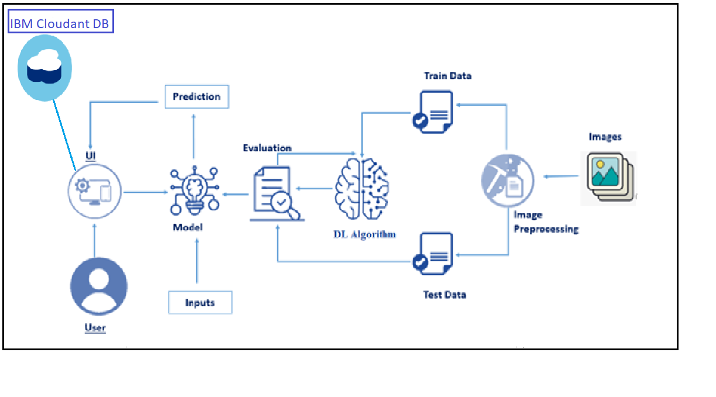

* 1. ***Hardware / Software designing:***

**To complete this project you should have the following software and packages.**

**Softwares:**

**Anaconda Navigator py charm**

**Visual studio code Jupiter notebook**

**IBM watson studio**

**Packages:**

**Tensor flow**

**Keras Flask numpy**

**Pandas**

1. **EXPERIMENTAL INVESTIGATIONS :**

Diabetic retinopathy (DR) is responsible for 0.8 million blind and 3.7 million visually impaired people globally in 2010. Due to the increasing number of diabetes patients, the number of DR patients has been estimated to be 191.0 million by 2030. Though the global prevalence of any DR was 27.0% for the period 2015 to 2019, there are no distinct symptoms at the early stages of DR, including the referable DR. Since DR can be fairly advanced before affecting vision timely diagnosis and treatment can reduce the risk of visual loss by approximately 57%. Therefore, routine screening and regular follow-up are essential for patients with diabetes, especially middle age and aged people. However, several studies have indicated that a significant amount of patients with diabetes failed to have recommended annual eye examination due to long examination time, lack of symptoms, and limited access to retinal specialists.

One of the efforts to resolve these barriers is the application of artificial intelligence (AI)techniques for DR detection and diagnosis. The developed a deep learning (DL) algorithm for DR evaluation. In the study, they trained their model using approximately 0.13 million training images. As a result, area under the receiver operating characteristic curve (AUC) values of 0.97–0.99 were obtained from tests using two separate data sets for detecting referable DR. Abramoff et al.It developed an automated system using convolutional neural networks (CNNs) for DR detection on a publicly available dataset. Since these pioneering studies, several research works focused on adopting DL technology for DR detection[12](https://www.nature.com/articles/s41598-021-81539-3#ref-CR12) and grading. Furthermore,prospectively validated the performance of a DR grading system comparing to that of manual grading across two sites in India. A deep learning system (DLS) considering glaucoma and age-related macular degeneration (AMD), as well as DR, was studied for multiethnic populations with diabetes These representative studies utilized conventional fundus photography, which captures the optic nerve and macula with a field of view (FOV) between 20∘ and 50∘. Though conventional fundus photography contains the most crucial region for DR detection and diagnosis, there is a large portion of the uncaptured retinal surface.

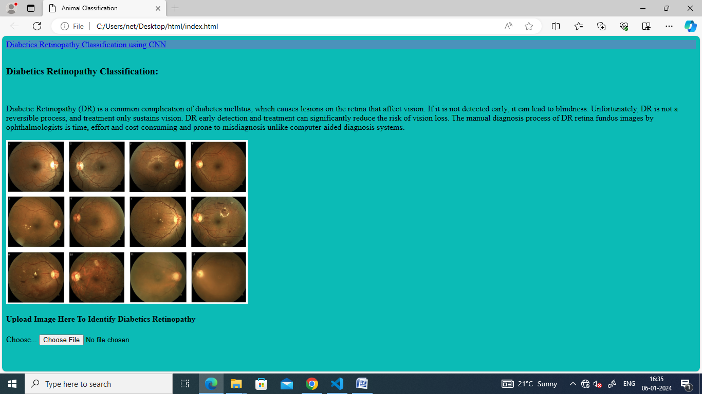

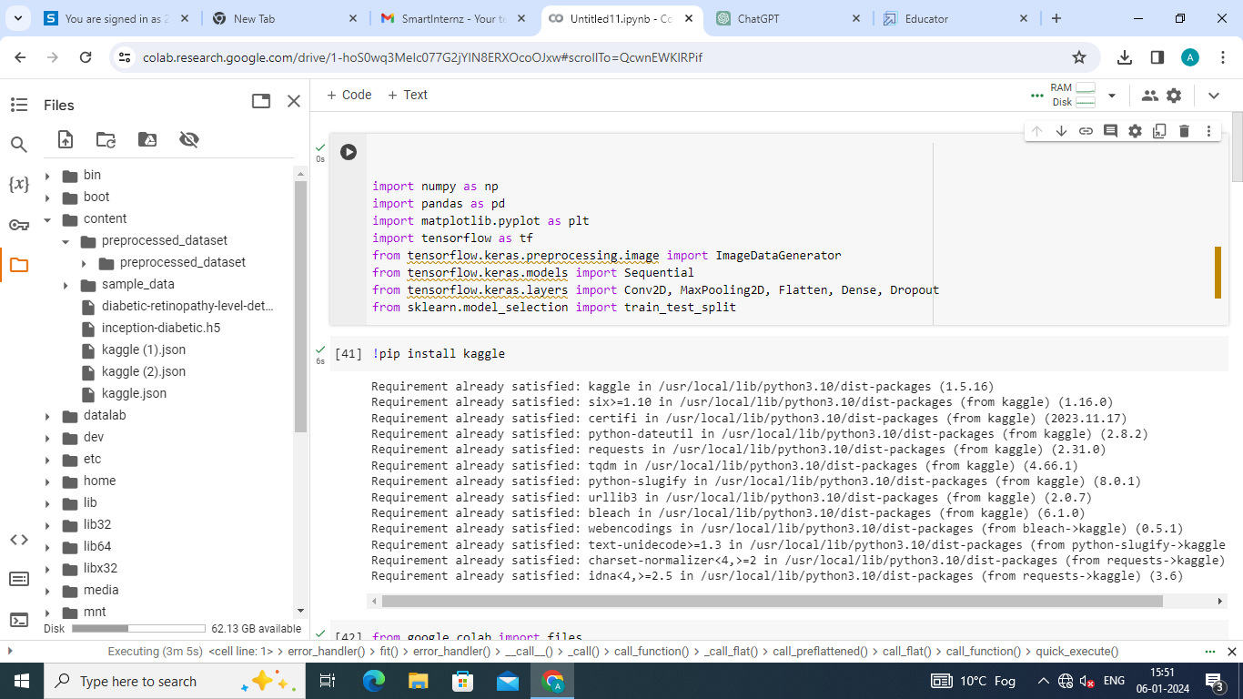

.

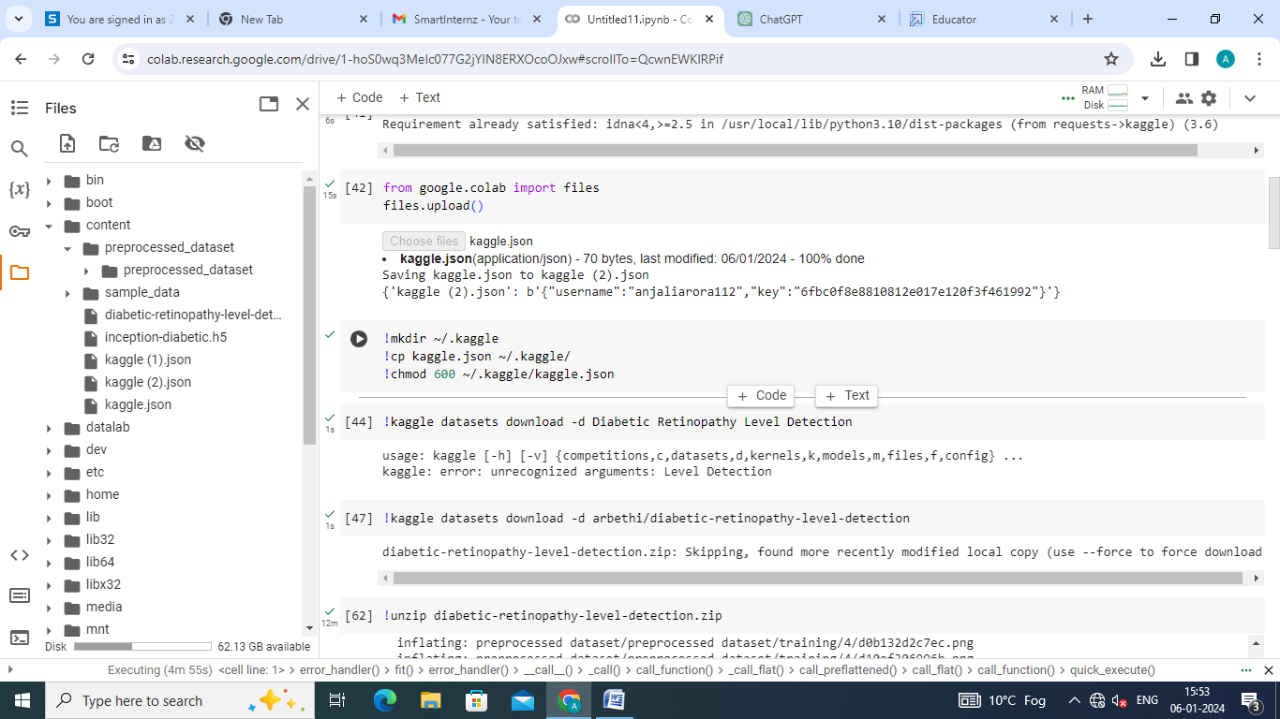

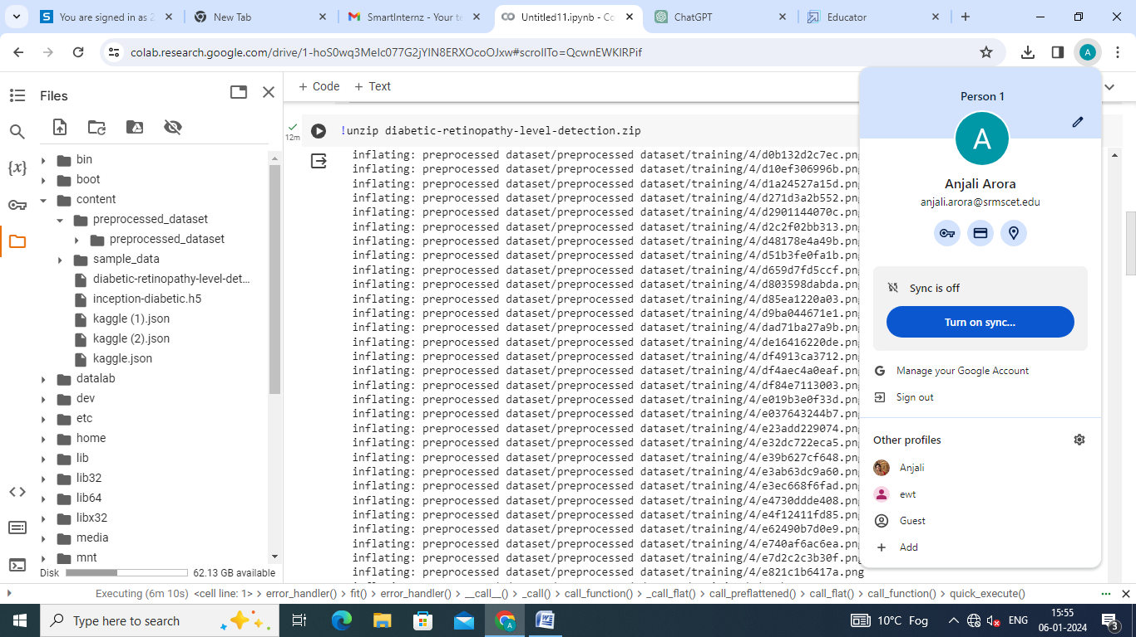

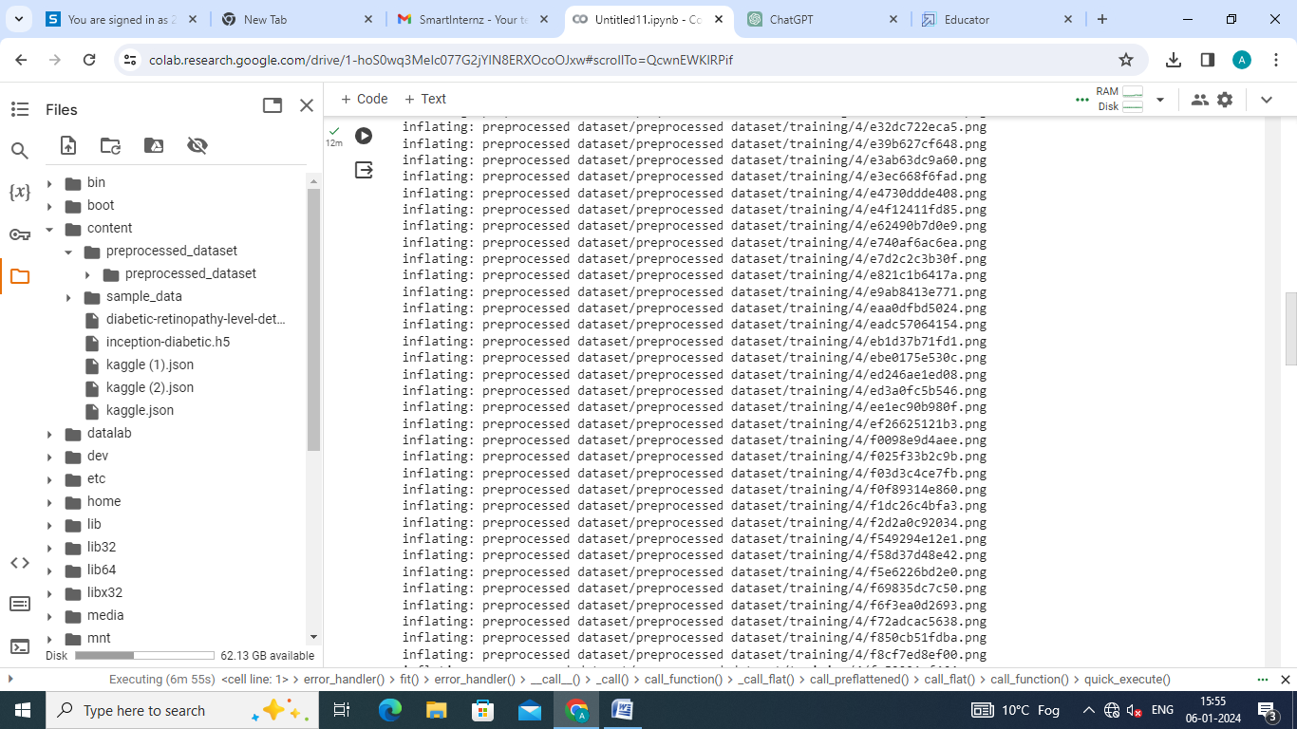

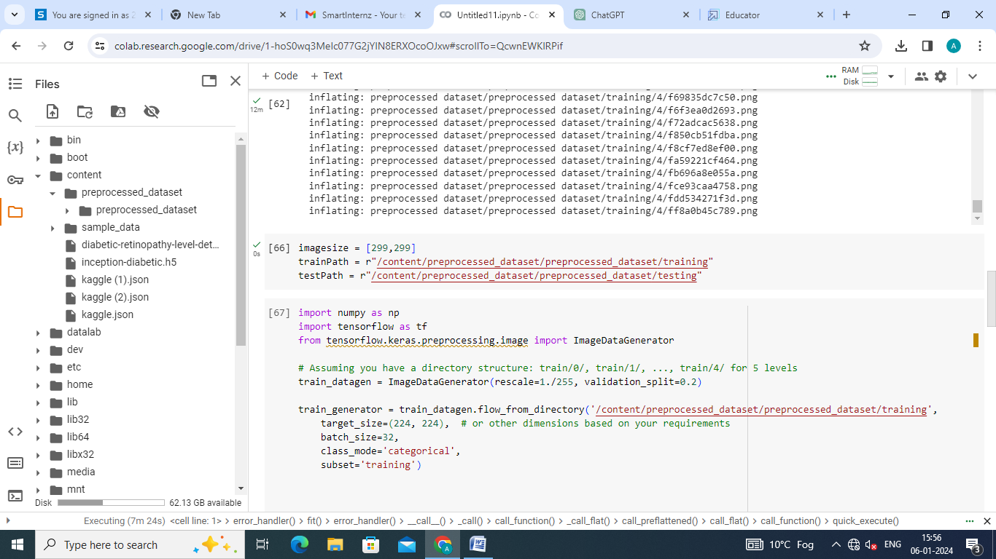

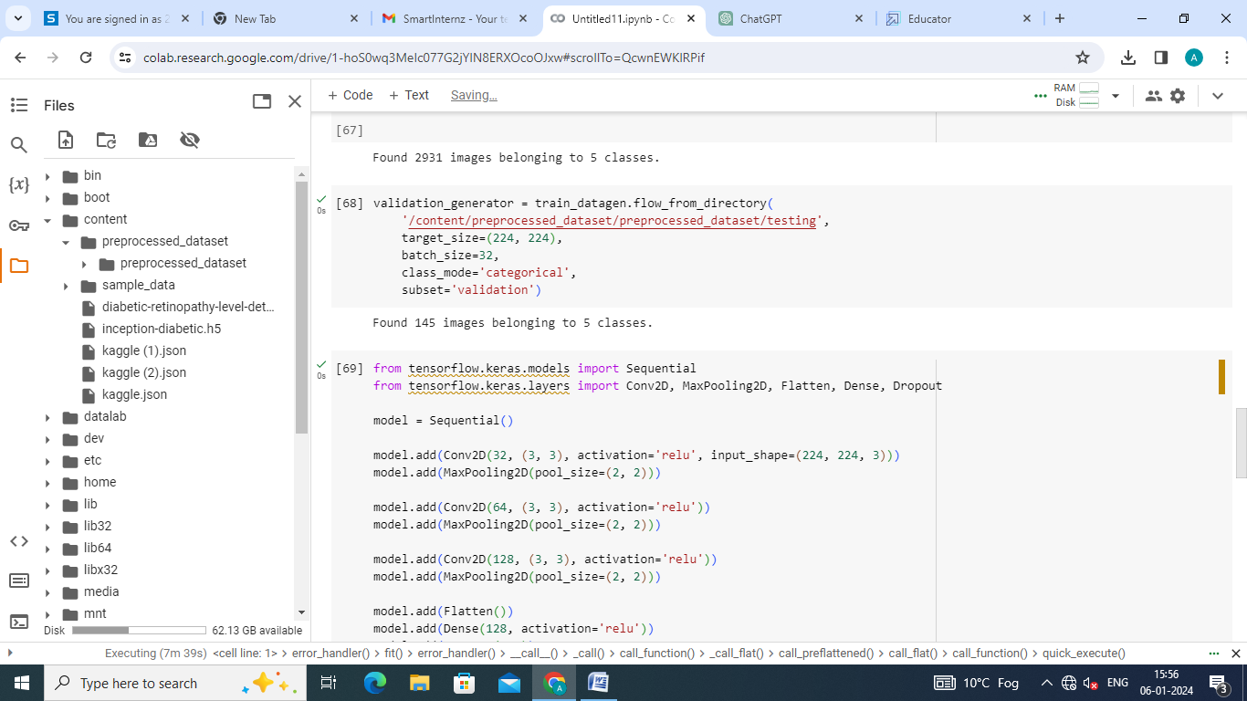

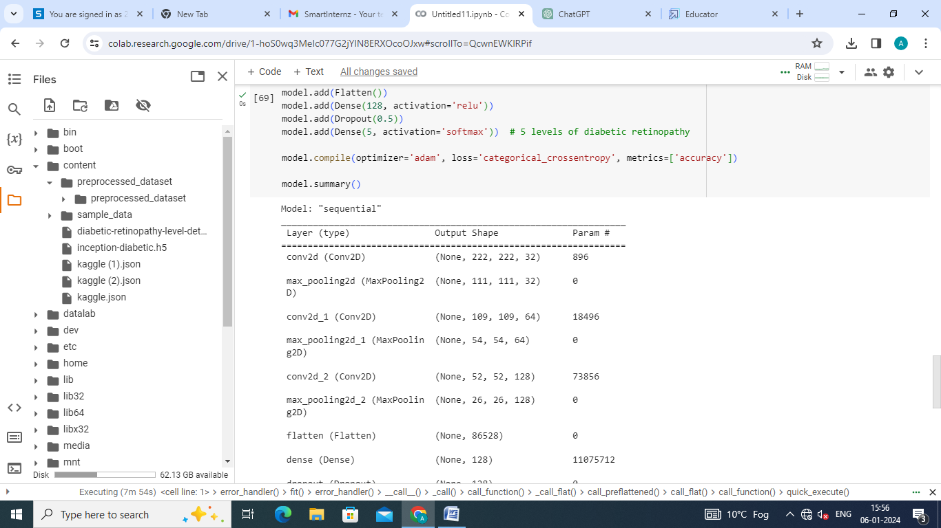

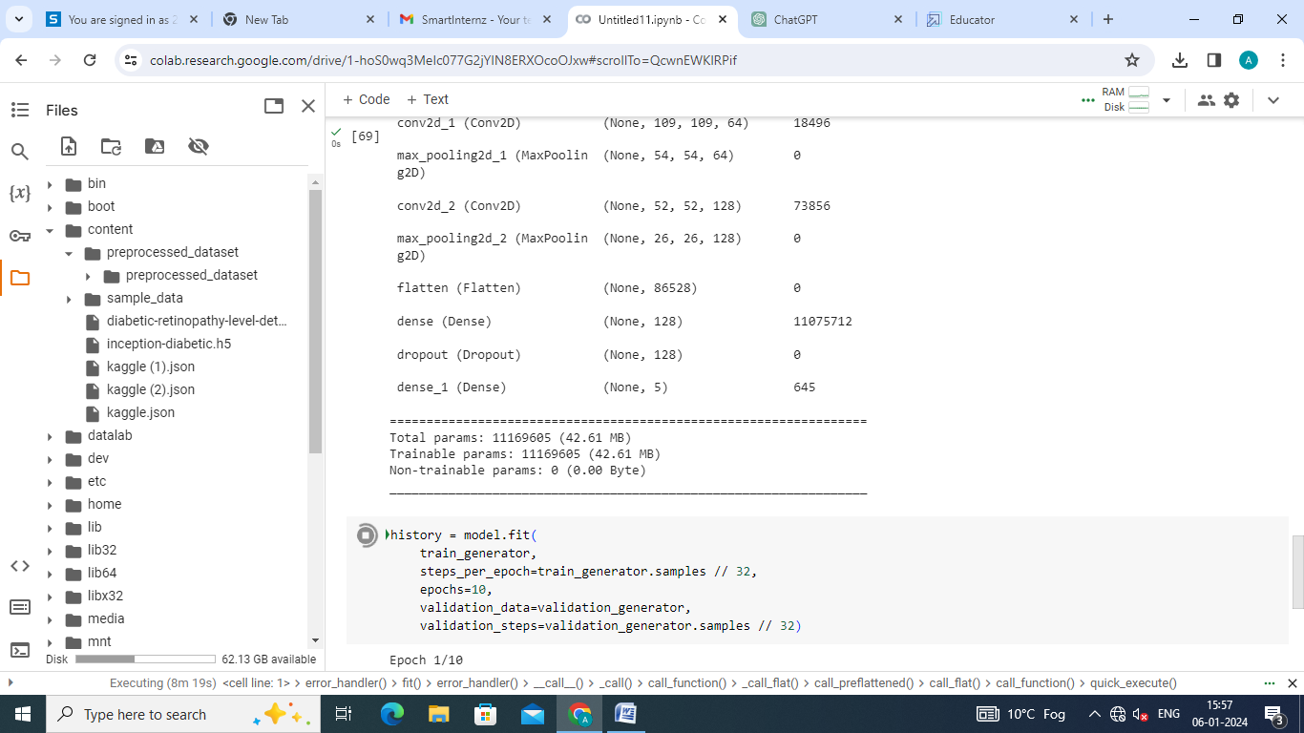



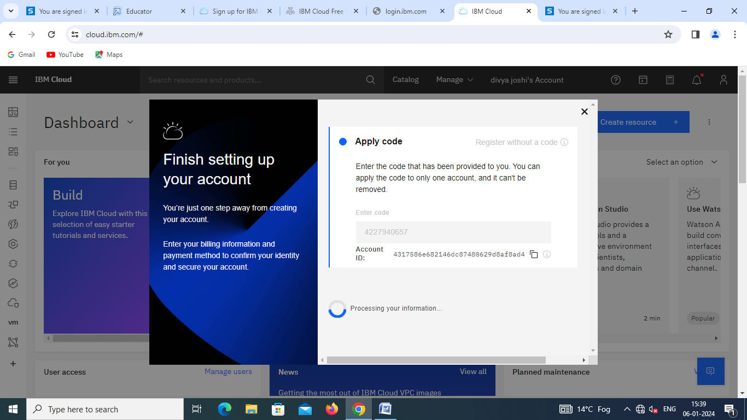

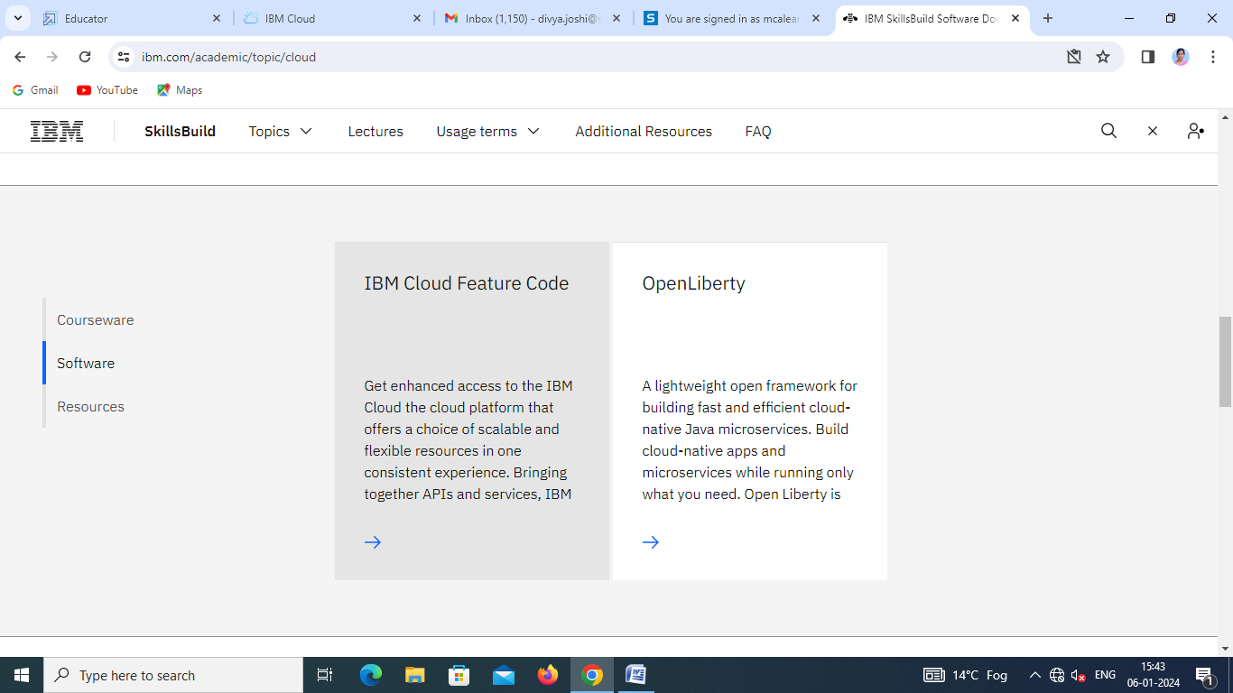

# FLOWCHART :

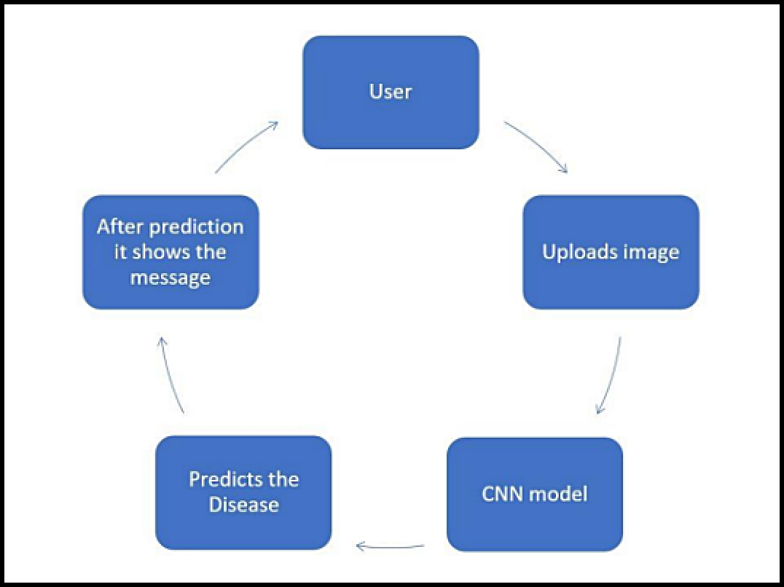

**To accomplish the above task you must complete the below activities and tasks :**

* Download the dataset.
* Classify the dataset into train and test sets.
* Add the neural network layers.
* Load the trained images and ﬁt the model.
* Test the model.
* Save the model and its dependencies.
* Build a Web application using a ﬂask that integrates with the model built.

# RESULT:



1. ***ADVANTAGES & DISADVANTAGES:***

**ADVANTAGES:**

* The proposed model could predict the disease just from the image of a particular Eye image.
* Easy to use UI
* Model has some good accuracy in detecting the diabetics Retinopathy

In recent years, the number of diseases on plants and the degree of harm caused has increased due to the variation in pathogen varieties, changes in cultivation methods, and inadequate plant protection techniques. Usage of such applications could help the farmers to necessary precautions so that they dont face any loss as such.

# FUTURE SCOPE :

As of now we have just build the web application which apparently takes the input as an image and then predict the out in the near future we can develop an application which computer vision and AI techniques to predict the infection once you keep the camera near the plant or leaf this could make our project even more usable.

# BIBILOGRAPHY :

[**http://www.ijstr.org/ﬁnal-print/nov2019/Fertilizers-Recommendation-**](http://www.ijstr.org/final-print/nov2019/Fertilizers-Recommendation-System%02For-Disease-Prediction-In-Tree-Leave.pdf)[**SystemFor-Disease-Prediction-In-Tree-Leave.pdf**](http://www.ijstr.org/final-print/nov2019/Fertilizers-Recommendation-System%02For-Disease-Prediction-In-Tree-Leave.pdf)

[**https://www.sciencedirect.com/science/article/pii/S0168169921004245**](https://www.sciencedirect.com/science/article/pii/S0168169921004245)

[**http://www.ijetajournal.org/volume-8/issue-2/IJETA-V8I2P1.pdf**](http://www.ijetajournal.org/volume-8/issue-2/IJETA-V8I2P1.pdf)

 [**https://www.semanticscholar.org/paper/Fertilizers-Recommendation-SystemFor-**](https://www.semanticscholar.org/paper/Fertilizers-Recommendation-System%02For-Disease-In-Neela-Nithya/495379d3ef2b461fabd2de8d0605c164cb1e396f)[**Disease-In-Neela-Nithya/495379d3ef2b461fabd2de8d0605c164cb1e396f**](https://www.semanticscholar.org/paper/Fertilizers-Recommendation-System%02For-Disease-In-Neela-Nithya/495379d3ef2b461fabd2de8d0605c164cb1e396f)

[**https://ieeexplore.ieee.org/document/8878781**](https://ieeexplore.ieee.org/document/8878781)

 [**https://www.irjet.net/archives/V7/i10/IRJET-V7I1004.pdf**](https://www.irjet.net/archives/V7/i10/IRJET-V7I1004.pdf)

**APPENDIX:**

 **A.Source Code:**

